**Java JDBC**

JDBC stands for Java Database Connectivity. JDBC is a Java API to connect and execute the query with the database. It is a part of JavaSE (Java Standard Edition). JDBC API uses JDBC drivers to connect with the database. There are four types of JDBC drivers:

* JDBC-ODBC Bridge Driver,
* Native Driver,
* Network Protocol Driver, and
* Thin Driver

We can use JDBC API to access tabular data stored in any relational database. By the help of JDBC API, we can save, update, delete and fetch data from the database. It is like Open Database Connectivity (ODBC) provided by Microsoft.

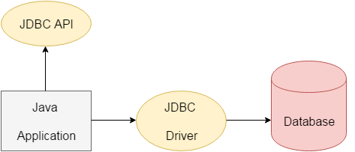

The **java.sql** package contains classes and interfaces for JDBC API. A list of popular interfaces of JDBC API are given below:

* Driver interface
* Connection interface
* Statement interface
* PreparedStatement interface
* CallableStatement interface
* ResultSet interface
* ResultSetMetaData interface
* DatabaseMetaData interface
* RowSet interface

A list of popular *classes* of JDBC API are given below:

* DriverManager class
* Blob class
* Clob class
* Types class

**Why Should We Use JDBC**

Before JDBC, ODBC API was the database API to connect and execute the query with the database. But, ODBC API uses ODBC driver which is written in C language (i.e. platform dependent and unsecured). That is why Java has defined its own API (JDBC API) that uses JDBC drivers (written in Java language).

We can use JDBC API to handle database using Java program and can perform the following activities:

1. Connect to the database
2. Execute queries and update statements to the database
3. Retrieve the result received from the database.

**What is API?**

API (Application programming interface) is a document that contains a description of all the features of a product or software. It represents classes and interfaces that software programs can follow to communicate with each other. An API can be created for applications, libraries, operating systems, etc.

**JDBC Driver**

|  |
| --- |
| JDBC Driver is a software component that enables java application to interact with the database. There are 4 types of JDBC drivers:   1. JDBC-ODBC bridge driver 2. Native-API driver (partially java driver) 3. Network Protocol driver (fully java driver) 4. Thin driver (fully java driver) |
| 1. **JDBC-ODBC bridge driver**   The JDBC-ODBC bridge driver uses ODBC driver to connect to the database. The JDBC-ODBC bridge driver converts JDBC method calls into the ODBC function calls. | |

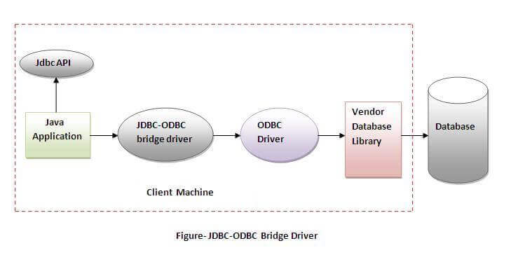

#### **In Java 8, the JDBC-ODBC Bridge has been removed.**

Oracle does not support the JDBC-ODBC Bridge from Java 8. Oracle recommends that you use JDBC drivers provided by the vendor of your database instead of the JDBC-ODBC Bridge.

**Advantages:**

* Easy to use.
* Can be easily connected to any database.

**Disadvantages:**

* Performance degraded because JDBC method call is converted into the ODBC function calls.
* The ODBC driver needs to be installed on the client machine.

|  |
| --- |
| 1. **Native-API driver**   The Native API driver uses the client-side libraries of the database. The driver converts JDBC method calls into native calls of the database API. It is not written entirely in java. |

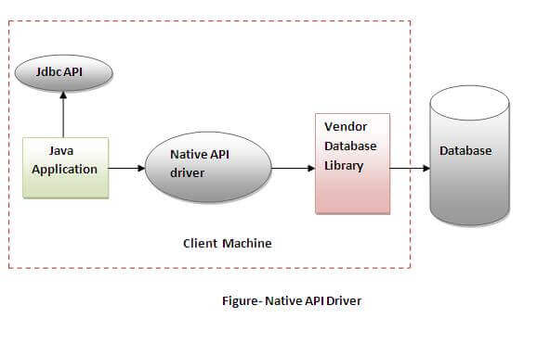

* **Advantage:**
* Performance upgraded than JDBC-ODBC bridge driver.
* **Disadvantage:**
* The Native driver needs to be installed on the each client machine.
* The Vendor client library needs to be installed on client machine.

1. **Network Protocol driver**

The Network Protocol driver uses middleware (application server) that converts JDBC calls directly or indirectly into the vendor-specific database protocol. It is fully written in java.

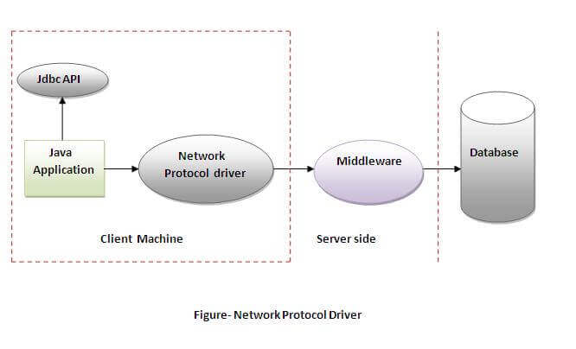

* **Advantage:**
* No client side library is required because of application server that can perform many tasks like auditing, load balancing, logging etc.
* **Disadvantages:**
* Network support is required on client machine.
* Requires database-specific coding to be done in the middle tier.
* Maintenance of Network Protocol driver becomes costly because it requires database-specific coding to be done in the middle tier.

|  |
| --- |
| 1. **Thin driver**   The thin driver converts JDBC calls directly into the vendor-specific database protocol. That is why it is known as thin driver. It is fully written in Java language. |

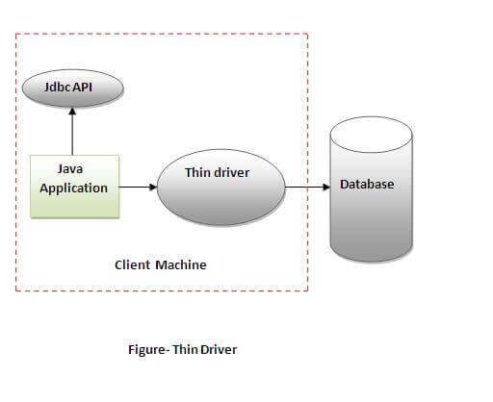

* **Advantage:**
* Better performance than all other drivers.
* No software is required at client side or server side.
* **Disadvantage:**
* Drivers depend on the Database.

**Java Database Connectivity Steps:**

There are 5 steps to connect any java application with the database using JDBC. These steps are as follows:

* **Register the Driver class**
* **Create connection**
* **Create statement**
* **Execute queries**
* **Close connection**

|  |
| --- |
|  |

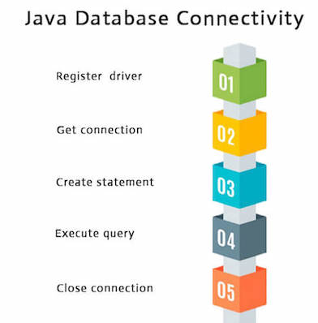

|  |
| --- |
| **1) Register the driver class**  The **forName()** method of Class is used to register the driver class. This method is used to dynamically load the driver class. |

**Syntax of forName() method**

**public** **static** **void** forName(String className)**throws** ClassNotFoundException **.**

**Example to register the OracleDriver class**

Here, Java program is loading oracle driver to esteblish database connection.

**Class.forName("oracle.jdbc.driver.OracleDriver");**

**2) Create the connection object**

|  |
| --- |
| The **getConnection()** method of DriverManager class is used to establish connection with the database. |

**Syntax of getConnection() method**

1) **public** **static** Connection getConnection(String url)**throws** SQLException

2) **public** **static** Connection getConnection(String url,String name,String password)

**throws** SQLException

**Example to establish connection with the Oracle database**

Connection con=DriverManager.getConnection(

"jdbc:oracle:thin:@localhost:8080:db","system","password");

**3) Create the Statement object**

|  |
| --- |
| The createStatement() method of Connection interface is used to create statement. The object of statement is responsible to execute queries with the database. |

**Syntax of createStatement() method**

**public** Statement createStatement()**throws** SQLException

**Example to create the statement object**

Statement stmt=con.createStatement();

|  |
| --- |
| **4.Execute the query**  The executeQuery() method of Statement interface is used to execute queries to the database. This method returns the object of ResultSet that can be used to get all the records of a table. |

**Syntax of executeQuery() method**

**public** ResultSet executeQuery(String sql)**throws** SQLException

**Example to execute query**

ResultSet rs=stmt.executeQuery("select * from emp");

**while**(rs.next()){

System.out.println(rs.getInt(1)+" "+rs.getString(2));

}

|  |
| --- |
| 1. **Close the connection object**   By closing connection object statement and ResultSet will be closed automatically. The close() method of Connection interface is used to close the connection. |

**Syntax of close() method**

**public** **void** close()**throws** SQLException

Example to close connection

**con.close();**

**Java Database Connectivity with MySQL**

To connect Java application with the MySQL database, we need to follow 5 following steps.

In this example we are using MySql as the database. So we need to know following informations for the mysql database:

1. **Driver class:**The driver class for the mysql database is **com.mysql.jdbc.Driver**.
2. **Connection URL:**The connection URL for the mysql database is **jdbc:mysql://localhost:3306/sonoo** where jdbc is the API, mysql is the database, localhost is the server name on which mysql is running, we may also use IP address, 3306 is the port number and emp is the database name. We may use any database, in such case, we need to replace the emp with our database name.
3. **Username:**The default username for the mysql database is **root**.
4. **Password:**It is the password given by the user at the time of installing the mysql database. In this example, we are going to use root as the password.

Let's first create a table in the mysql database, but before creating table, we need to create database first.

1. create database emp;
2. use emp;
3. create table empdata(id **int**(10),name varchar(40),age **int**(3));

**Example to Connect Java Application with mysql database**

In this example, emp is the database name, root is the username and password both.

1. **import** java.sql.*;
2. **class** MysqlCon{
3. **public** **static** **void** main(String args[]){
4. **try**{
5. Class.forName("com.mysql.jdbc.Driver");
6. Connection con=DriverManager.getConnection(
7. "jdbc:mysql://localhost:3306/emp","root","root");
8. //here emp is database name, root is username and password
9. Statement stmt=con.createStatement();
10. ResultSet rs=stmt.executeQuery("select * from emp");
11. **while**(rs.next())
12. System.out.println(rs.getInt(1)+"  "+rs.getString(2)+"  "+rs.getString(3));
13. con.close();
14. }**catch**(Exception e){ System.out.println(e);}
15. }
16. }

To connect java application with the mysql database, **mysqlconnector.jar** file is required to be loaded.

Download mysqlconnector jar

**Two ways to load the jar file:**

1. Paste the mysqlconnector.jar file in jre/lib/ext folder
2. Set classpath

Paste the mysqlconnector.jar file in JRE/lib/ext folder:

|  |
| --- |
| Download the mysqlconnector.jar file. Go to jre/lib/ext folder and paste the jar file here. |

|  |
| --- |
| 2) Set classpath:  There are two ways to set the classpath:   * temporary * permanent |

|  |
| --- |
| How to set the temporary classpath  open command prompt and write: |

C:>set classpath=c:\folder\mysql-connector-java-5.0.8-bin.jar;.;

How to set the permanent classpath

Go to environment variable then click on new tab. In variable name write **classpath** and in variable value paste the path to the mysqlconnector.jar file by appending mysqlconnector.jar;.; as C:\folder\mysql-connector-java-5.0.8-bin.jar;.;

**Statement**

The Statement interface represents the static SQL statement. It helps you to create a general purpose SQL statements using Java.

**Creating a statement**

You can create an object of this interface using the **createStatement()** method of the **Connection** interface.

Create a statement by invoking the **createStatement()** method as shown below.

Statement stmt = null;

try {

stmt = conn.createStatement( );

. . .

}

catch (SQLException e) {

. . .

}

finally {

. . .

}

**Executing the Statement object**

Once you have created the statement object you can execute it using one of the execute methods namely, execute(), executeUpdate() and, executeQuery().

* **execute():** This method is used to execute SQL DDL statements, it returns a boolean value specifying whether the ResultSet object can be retrieved.
* **executeUpdate():** This method is used to execute statements such as insert, update, delete. It returns an integer value representing the number of rows affected.
* **executeQuery():** This method is used to execute statements that returns tabular data (example SELECT statement). It returns an object of the class ResultSet.

**Prepared Statement**

The **PreparedStatement** interface extends the Statement interface. It represents a precompiled SQL statement which can be executed multiple times. This accepts parameterized SQL quires and you can pass 0 or more parameters to this query.

Initially, this statement uses place holders “**?**” instead of parameters, later on, you can pass arguments to these dynamically using the **setXXX()** methods of the **PreparedStatement** interface.

**Creating a PreparedStatement**

You can create an object of the **PreparedStatement** (interface) using the **prepareStatement()** method of the Connection interface. This method accepts a query (parameterized) and returns a PreparedStatement object.

When you invoke this method the Connection object sends the given query to the database to compile and save it. If the query got compiled successfully then only it returns the object.

To compile a query, the database doesn’t require any values so, you can use (zero or more) **placeholders** (Question marks “?”) in the place of values in the query.

For example, if you have a table named **Employee** in the database created using the following query:

CREATE TABLE Employee(Name VARCHAR(255), Salary INT NOT NULL, Location

VARCHAR(255));

Then, you can use a **PreparedStatement**to insert values into it as shown below.

//Creating a Prepared Statement

String query="INSERT INTO Employee(Name, Salary, Location)VALUES(?, ?, ?)";

Statement pstmt = con.prepareStatement(query);

## **Setting values to the place holders**

The **PreparedStatement** interface provides several setter methods such as setInt(), setFloat(), setArray(), setDate(), setDouble() etc.. to set values to the place holders of the prepared statement.

These methods accepts two arguments one is an integer value representing the placement index of the place holder and the other is an int or, String or, float etc… representing the value you need to insert at that particular position.

Once you have created a prepared statement object (with place holders) you can set values to the place holders of the prepared statement using the setter methods as shown below:

pstmt.setString(1, "Amit");

pstmt.setInt(2, 3000);

pstmt.setString(3, "Hyderabad");

**Executing the Prepared Statement**

Once you have created the **PreparedStatement** object you can execute it using one of the **execute()** methods of the **PreparedStatement** interface namely, execute(), executeUpdate() and, executeQuery().

* **execute():** This method executes normal static SQL statements in the current prepared statement object and returns a boolean value.
* **executeQuery():** This method executes the current prepared statement and returns a **ResultSet** object.
* **executeUpdate():** This method executes SQL DML statements such as insert update or delete in the current Prepared statement. It returns an integer value representing the number of rows affected.

**CallableStatement**

The **CallableStatement** interface provides methods to execute stored procedures. Since the JDBC API provides a stored procedure SQL escape syntax, you can call stored procedures of all RDBMS in a single standard way.

**Creating a CallableStatement**

You can create an object of the **CallableStatement** (interface) using the **prepareCall()** method of the **Connection** interface.

This method accepts a string variable representing a query to call the stored procedure and returns a **CallableStatement** object.

A CallableStatement can have input parameters or, output parameters or, both. To pass input parameters to the procedure call you can use place holder and set values to these using the setter methods (setInt(), setString(), setFloat()) provided by the CallableStatement interface.

Suppose, you have a procedure name myProcedure in the database you can prepare a callable statement as:

//Preparing a CallableStatement

CallableStatement cstmt = con.prepareCall("{call myProcedure(?, ?, ?)}");

## **Setting values to the input parameters**

You can set values to the input parameters of the procedure call using the setter methods.

These accept two arguments one is an integer value representing the placement index of the input parameter and the other is an int or, String or, float etc… representing the value you need to pass an input parameter to the procedure.

**Note:** Instead of index you can also pass the name of the parameter in String format.

cstmt.setString(1, "Raghav");

cstmt.setInt(2, 3000);

cstmt.setString(3, "Hyderabad");

**Executing the Callable Statement**

Once you have created the CallableStatement object you can execute it using one of the **execute()** method.

cstmt.execute();

**Statement interface**

The **Statement interface** provides methods to execute queries with the database. The statement interface is a factory of ResultSet i.e. it provides factory method to get the object of ResultSet.

**The important methods of Statement interface are as follows:**

|  |
| --- |
| **1) public ResultSet executeQuery(String sql):** is used to execute SELECT query. It returns the object of ResultSet. |
| **2) public int executeUpdate(String sql):** is used to execute specified query, it may be create, drop, insert, update, delete etc. |
| **3) public boolean execute(String sql):** is used to execute queries that may return multiple results. |
| **4) public int[] executeBatch():** is used to execute batch of commands |

**Example of Statement interface**

Let’s see the simple example of Statement interface to insert, update and delete the record.

1. **import** java.sql.*;
2. **class** FetchRecord{
3. **public** **static** **void** main(String args[])**throws** Exception{
4. Class.forName("oracle.jdbc.driver.OracleDriver");
5. Connection con=DriverManager.getConnection("jdbc:oracle:thin:@localhost:1521:xe","root","root");
6. Statement stmt=con.createStatement();
8. //stmt.executeUpdate("insert into emp values(33,'Jack',50000)");
9. //int result=stmt.executeUpdate("update emp set name='Kim',salary=10000 where id=33");
10. **int** result=stmt.executeUpdate("delete from emp where id=33");
11. System.out.println(result+" records affected");
12. con.close();
13. }}

**ResultSet interface:**

The object of ResultSet maintains a cursor pointing to a row of a table. Initially, cursor points to before the first row.

By default, ResultSet object can be moved forward only and it is not updatable.

But we can make this object to move forward and backward direction by passing either TYPE_SCROLL_INSENSITIVE or TYPE_SCROLL_SENSITIVE in createStatement(int,int) method as well as we can make this object as updatable by: